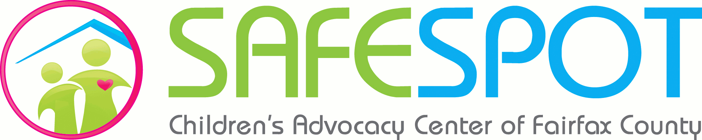

- Virginia Department of Health has a public helpline for questions about COVID-19: 1-877-275-8343. Community resource specialists are available to answer questions to the public in English and Spanish.
- Dominion Energy has suspended all service disconnections for nonpayment at this time. They are reconnecting customers whose services were shut off.
  - https://www.dominionenergy.com/company/coronavirus
- Washington Gas has suspended all service disconnections and are waiving late fees on customer bills. These actions are automatically in place and do not need to be requested. They are also offering payment arrangements as needed.
  - https://www.washingtongas.com/
- Fairfax County CSB is offering telehealth services via Zoom for therapy, case-management, and medication management. Their emergency mental health services (including the Merrifield Center) and the Fairfax Detoxification Center are still operating as usual.
  - CSB sites have adjusted their hours until further notice. Please see PDF for specifics.
- Fairfax County Public Schools is offering free meal pickup at several locations. Breakfast will be available from 8 to 10:30 a.m., and lunch will be from 10:30 a.m. to 2 p.m. Meals will be free for all students. Adult lunches are available for purchase for $2. FCPS plans to reassess the situation by Friday, March 27.
  - For a list of pickup locations and more information, please visit https://www.fcps.edu/news/fcps-provides-emergency-breakfast-and-lunch-school-sites-pop-locations-and-along-some-bus
- Falls Church City Public Schools is providing a two-week supply of nonperishable food upon the two-week school closure for all families enrolled in the free and reduced school lunch program. The distribution event will take place at Thomas Jefferson Elementary, and delivery will be available if requested. Families are encouraged to reach out to their designated social workers. For more information, please visit fccps.org.
- Food Distribution-Searchable Map https://fairfaxcountyemergency.wpcomstaging.com/2020/03/18/find-food-resources-in-fairfax-countyduring-covid-19-emergency/
- Northern Virginia Family Services (NVFS) has many programs that may be helpful.
  - NVFS Emergency Assistance Program – individuals who have lost/reduced income from employment as a result of COVID-19 or who have unforeseen expenses (healthcare, childcare, etc.). Please instruct clients to utilize all other resources prior to requesting this last resort funding. Funds will be distributed on a first-come first-served basis for immediate needs. There is a lengthy application process, and clients must be able to provide documentation that their hardship is linked to the COVID-19 pandemic.
    - https://www.nvfs.org/covid-19-emergency-assistance-program/
  - Food assistance – they are bypassing most documentation requirements for eligibility.
    - http://www.nvfs.org/wp-content/uploads/2020/03/NVFS-COVID-19-Response-Plan-Hunger-Resource-Center.pdf
- Catholic Charities may be a helpful resource for individuals needing emergency rent and utility assistance (although clients should not be facing utility emergencies as a result of the new protocols in place from Dominion & WG).
  - Clients should email requesting assistance and include their name, phone number, and city/county
    - Christ House (Alexandria) – ea-ch@ccda.net
      - All Fairfax County except Reston & Herndon
    - Leesburg Regional Office – ea-lro@ccda.net
      - Reston & Herndon residents can go here
    - Loaves & Fishes (Front Royal) – ea-lro@ccda.net
  - Client will need to provide 1 proof of income (paystubs, SSI/SSDI, child-support, etc.)
  - Please review the website for more specific information https://www.ccda.net/need-help/rent,-utility-assistance,-and-basic-household-needs/
- Coordinated Services Planning can provide basic county information and link clients to resources for emergency needs. Clients can call M-F 8am-4:30pm 703-222-0880.
- Cornerstones (Reston/Herndon) assists families facing eviction and homelessness.
  - Assistance Services & Pantry Program: https://www.cornerstonesva.org/services/food-financial-or-urgent-assistance/foods-and-basic-needs/
- Committee for Helping Others (Vienna, Oakton, Dunn Loring, & Merrifield areas) provides limited financial assistance, personal care items, and emergency food assistance.
  - Food and clothing stores are closed, but the emergency services team is open to provide financial assistance. For financial assistance, call 703-281-7614 and leave a message in box 4, or email cho@cho-va.com. Please provide a home address in any communication (voicemail or email).
    - https://cho-va.com/services/financial-aid/
- Nativity Catholic Church (Burke) has a few programs that may be helpful
  - The Lamb Center is a Christian-based day-time drop-in center that provides laundry, showers, hot meals, counseling, and emergency financial assistance. It is open 8am-3pm M-F and 8am-12:30pm on Saturday.
    - https://www.thelambcenter.org/
- Koinonia (Franconia/Springfield) can provide emergency financial assistance and food assistance. All requests will be handled via phone 703-971-1991.
  - http://www.koinoniacares.org/get-help.html
- Lorton Community Action Center is operating on a reduced schedule but still has support programs open Monday, Tuesday, and Thursday. They can provide financial assistance and emergency food assistance
  - Basic needs programs – call 703-339-5161 and use extensions x171, x110, or x120.
- John Woods, owner of 29Diner, has offered to provide local families with food (either prepared meals or pantry/refrigerated ingredients) throughout this time. Please instruct clients to call John directly (703-715-7886) and leave a voicemail stating they are interested in the Community First program. He will call them back to coordinate pick-up/drop off.
  - www.29diner.com

